CO1-AT1 – Case Study Analysis Report
Problem Statement: AI-Based Fashion Supply Chain Optimization Platform
NAME: D. Vyshali | SLOT: D
REGNO: 192411197 | COURSE CODE: CSA1007

1. Understand the Problem Statement
Fashion retail runs on trends that change within weeks, but most supply chain planning still runs on spreadsheets and gut-feel reorder rules built for a slower era. The AI-Based Fashion Supply Chain Optimization Platform is designed to close that gap — it helps fashion retailers and manufacturers forecast demand, allocate inventory, and coordinate suppliers using AI/ML instead of manual, spreadsheet-driven planning.
- Objectives: Forecast product demand, optimize inventory allocation, coordinate suppliers, track shipments, monitor sales trends, and generate supply chain reports.
- Scope: Demand forecasting, inventory allocation, supplier coordination, shipment tracking, sales trend monitoring, and analytics reporting across warehouses, stores, and e-commerce channels.
- Target Users: Merchandising planners who decide what to buy, procurement teams who place orders, warehouse staff who move stock, and executives who need a single view of how the supply chain is performing.
- Why It Matters Now: Fast fashion cycles, omni-channel retail, and rising customer expectations for quick delivery have made manual planning too slow to keep up with actual demand.
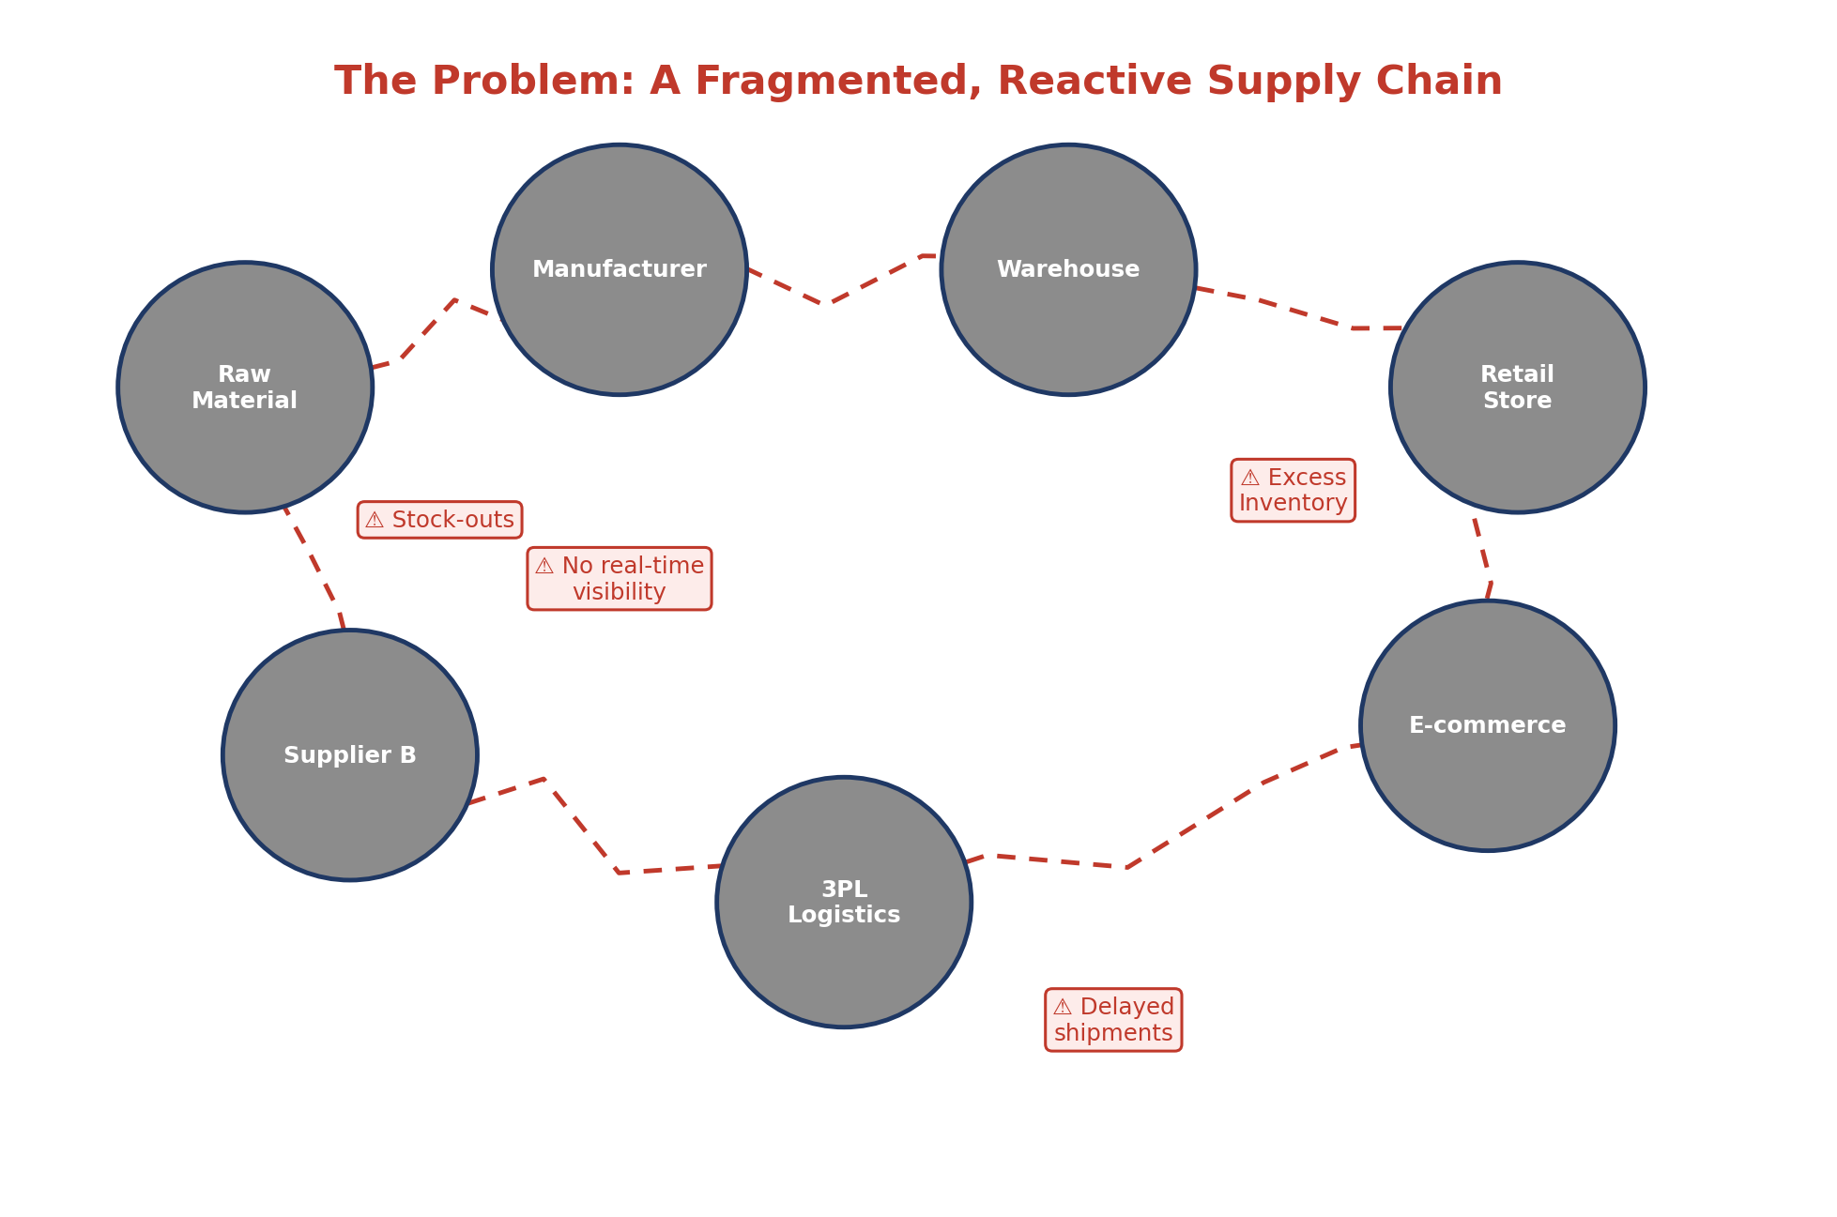
Fig 1: The current, fragmented supply chain this platform is meant to fix.

2. Identify Key Stakeholders and Challenges
- Stakeholders: Merchandising Planners, Procurement Managers, Warehouse Managers, Retail/E-commerce Channel Managers, Suppliers, Executive Management.
- Roles: Planners decide what to buy; procurement raises and tracks orders; warehouse managers handle stock placement; channel managers keep stores/e-commerce stocked; suppliers fulfil production; executives track overall performance.
- Challenges: Inaccurate demand forecasting, stock-outs and overstock happening at the same time, slow supplier coordination, no real-time shipment visibility, and data scattered across disconnected systems.
- Cross-Stakeholder Friction: Planners and procurement often work off different numbers because there's no shared, live source of truth — by the time a spreadsheet is updated, the actual stock position has already changed.
- Supplier-Side Challenges: Suppliers frequently get demand signals late, over email threads with no structure, which pushes production schedules and delivery timelines further out than necessary.
Stakeholder | Main Concern
Merchandising Planner | Accurate, SKU-level demand forecasts each season
Procurement Manager | Faster, trackable coordination with suppliers
Warehouse Manager | Optimal stock allocation and delay alerts
Executive Management | One consolidated view of supply chain performance

3. Analyze the Current Approach
- Current Process: Demand is estimated from historical sales averages in spreadsheets; purchase orders are coordinated with suppliers over email and phone; stock is reordered using fixed, static rules.
- Strengths: Relies on experienced planners and long-standing supplier relationships; simple to run with no special tooling; low upfront cost since it needs no new infrastructure.
- Limitations: Reactive rather than predictive, slow to respond to fast-changing fashion trends, and prone to human error during peak season when order volumes spike.
- Gaps: No real-time inventory visibility, no automated demand forecasting, and no single system connecting suppliers, warehouses, and retail channels.
- Cost of the Gaps: Every stock-out is a lost sale, every markdown on excess inventory is lost margin, and every delayed shipment chips away at customer trust — none of which the current process can see coming in advance.
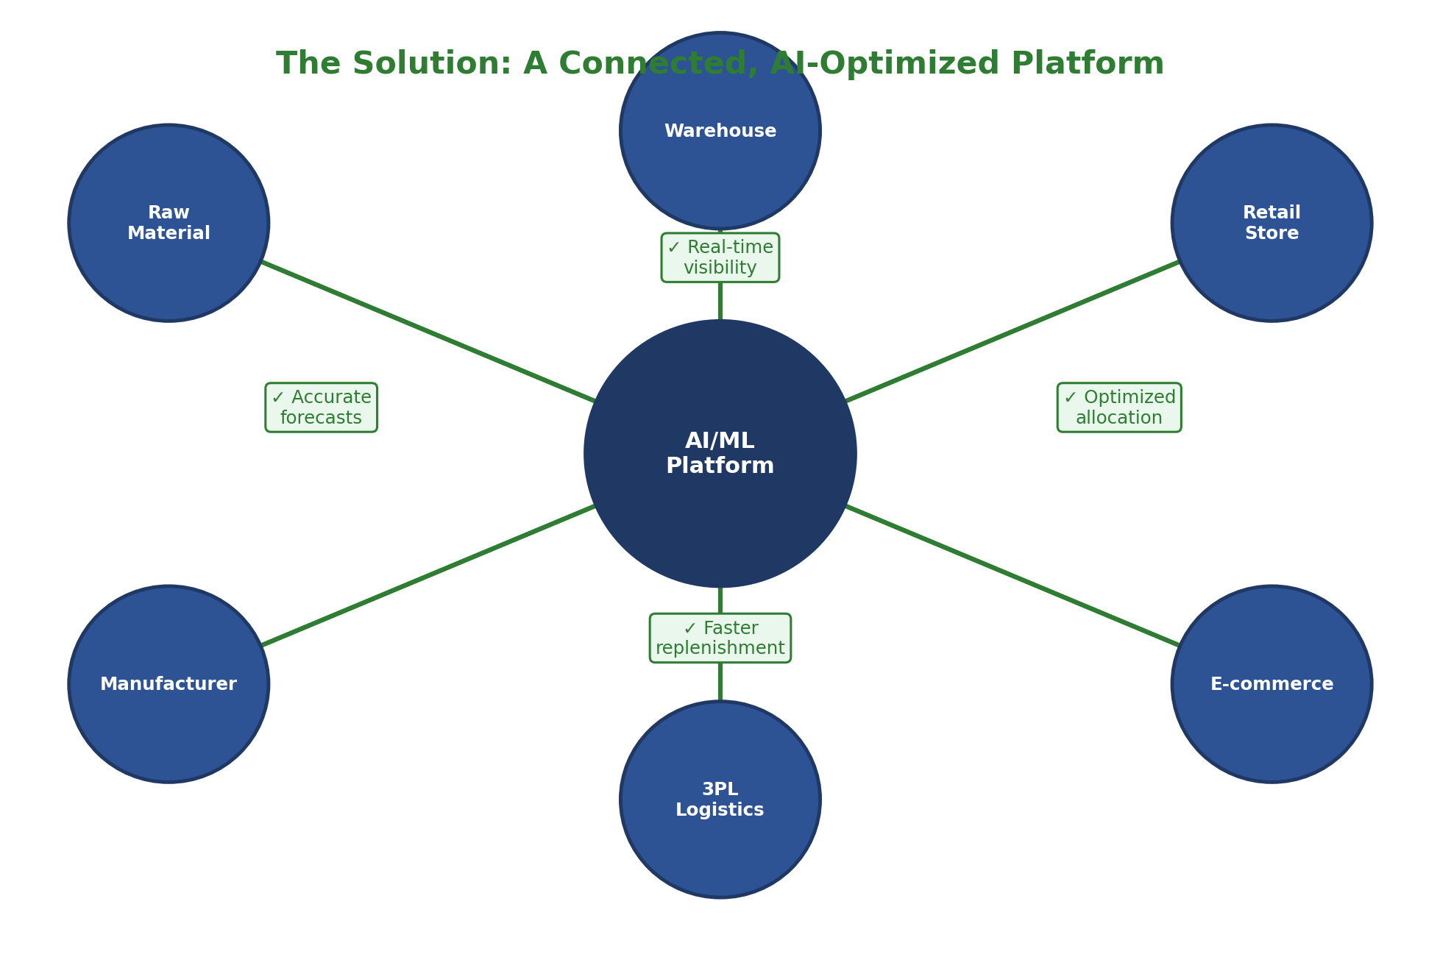
Fig 2: The proposed solution — one connected platform in place of scattered spreadsheets and email threads.

4. Proposed Software Solution Using Software Engineering Principles
- Modules: Demand Forecasting, Inventory Allocation, Supplier Coordination, Shipment Tracking, Sales Trend Monitoring, and Reporting & Analytics.
- Functional Requirements: Forecast SKU-level demand, recommend stock allocation, manage purchase orders, track shipments in real time, and generate consolidated reports.
- Non-Functional Requirements: Security, scalability, reliability, maintainability, usability, and performance under peak seasonal load.
- Software Engineering Principles: Modular, layered microservices architecture; horizontal scalability; secure API-based integration with supplier and retail systems; and a maintainable, well-documented codebase.
- Data Flow: Sensor, POS, and supplier data feeds into a central pipeline, which trains the forecasting and allocation models that ultimately drive purchase orders, shipment tracking, and dashboards.
Module | Primary Purpose
Demand Forecasting | Predict SKU-level demand from historical and seasonal data
Inventory Allocation | Recommend stock distribution across warehouses and channels
Supplier Coordination | Manage purchase orders and production schedules
Shipment Tracking | Give real-time visibility from supplier to warehouse
Reporting & Analytics | Consolidate performance data for planners and executives

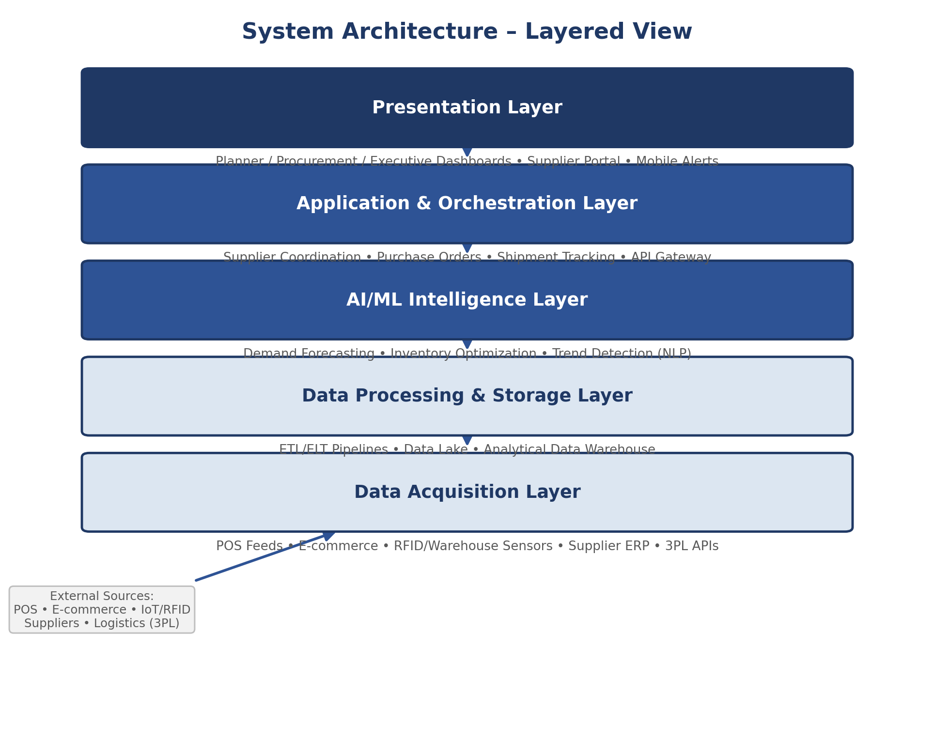
Fig 3: Proposed layered system architecture.

5. Justify the Chosen Methodology/Framework
- Selected SDLC Model: Agile Scrum.
- Justification: The AI/ML forecasting and allocation components need iterative tuning against real sales data, and fashion retail priorities shift quickly each season — Scrum's short, incremental sprints suit both far better than a fixed Waterfall plan.
- Benefits: Faster feedback from planners and procurement teams, easier course-correction if a forecasting model underperforms, and lower overall project risk.
- Why Not Waterfall: A single, upfront design would lock in assumptions about demand patterns before any forecasting model has actually been tested against real data — too risky for a fast-moving industry like fashion.
- Delivery Approach: Each 2-week sprint delivers one working slice of the platform — starting with forecasting and allocation, then supplier coordination and tracking, and finally reporting dashboards.
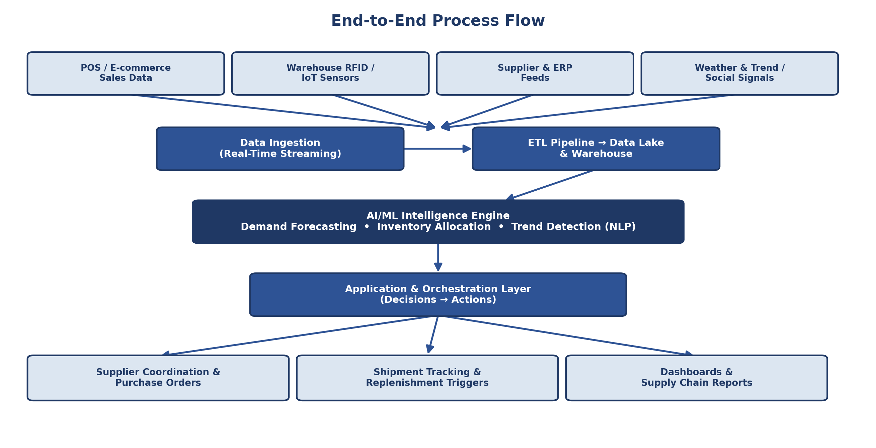
Fig 4: End-to-end process flow, from raw data to purchase orders and dashboards.

6. Expected Outcomes and Limitations
- Expected Outcomes: Reduced stock-outs and excess inventory, faster supplier coordination, real-time shipment visibility, and more accurate demand planning.
- How Challenges Are Addressed: AI-driven forecasting replaces guesswork, a unified supplier portal replaces email/phone coordination, and real-time dashboards close the visibility gap.
- Limitations: Initial setup and integration cost, dependency on clean historical sales data, and a learning curve for staff moving off spreadsheets.
- Future Enhancements: NLP-based trend detection from social media, deeper IoT integration in warehouses, and cloud-based scaling for global supplier networks.
- Long-Term Impact: Over multiple seasons, the platform's forecasts should keep improving as more real sales data flows back into the models — something a static, spreadsheet-based process could never do on its own.
Current Challenge | Platform's Response
Inaccurate demand forecasting | SKU-level AI forecasting from real sales history
Slow supplier coordination | Unified digital purchase-order portal
No shipment visibility | Real-time shipment tracking and delay alerts
Scattered, disconnected data | Single consolidated reporting dashboard

Code of Conduct:
I, D. Vyshali – 192411197 (Name / Reg No), certify that this submission is my original work and that I have adhered to the guidelines specified for this assessment. I understand that any violation of academic integrity rules will result in disciplinary action.
Signature of the student: D.vyshali
Date: 16/07/26

